Reindeer Hunter

Version 3

# Third-Party Libraries Used

The following third-party libraries were used as part of the Reindeer Hunter program:

* IText Sharp
* FileHelpers
* Json.net

The usage rights of these libraries are governed by the Open Source License.

Content

Third-Party Libraries Used 1

Introduction to Reindeer Hunter 1

Usage of Reindeer Hunter code 1

Prerequisites 1

Student Information Spreadsheet 2

Student Results Spreadsheet 2

Student License Form Template 2

First-time setup 4

Home Page 4

Filters and Search 8

Match ID 8

Properties Window 9

Free For All Page 9

# Introduction to Reindeer Hunter

The Reindeer Hunter program was created to facilitate the process of managing the Sacred Heart annual Reindeer Hunt, put on by the Student Council of Sacred Heart High School in Stittsville near Christmas time.

# Usage of Reindeer Hunter code

The Reindeer Hunter code is owned by Kyle Anderson. The code for the Reindeer Hunter program is open source, and can be modified and used without permission by the owner. It is available at <https://github.com/eAUE/Reindeer-Hunter>.

Feel free to suggest features or improvements.

# Prerequisites

## Student Information Spreadsheet

The student information spreadsheet is a spreadsheet containing information on all the students that are to be imported into the program. From this spreadsheet, a comma separated values file which can be imported by the program can be generated. The spreadsheet must be of the following format to work properly with the Reindeer Hunter program:

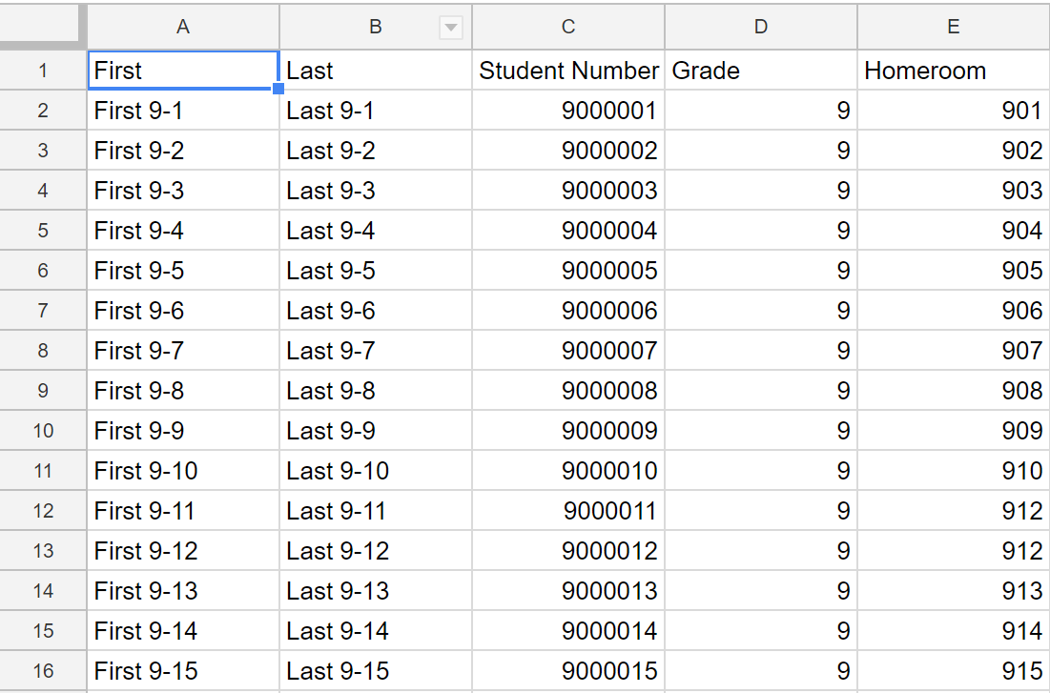

If any of those fields are empty, then an error will be raised when the comma separated values file is imported.

## Student Results Spreadsheet

The student result spreadsheet is an easy way to input multiple match results into the program at once, using a comma separated values file generated by the spreadsheet. The spreadsheet should be of the following format:



The Timestamp is ignored by the program, so it can be empty. To function properly on import, either the Student’s First Name; Last Name and Homeroom fields must be filled in correctly **or** just the student’s number **or** all of the fields must be filled in correctly.

Convert the spreadsheet to a comma separated values format and it can be imported via the Import Match Results menu option in the Home Page. See Home Page.

## Student License Form Template

When the instant print function is used in the Reindeer Hunter program, the app will look for a template PDF file to duplicate and fill in its data directory. If such a file does not exist, it will open a prompt asking for one. Therefore, the license form template must be of proper format.

It must be a PDF file with form fields named correctly and have 8 licenses per page.

A free and easy to use tool to create PDF forms that would work for the Reindeer Hunter application could be with the [PDFEscape online editor.](https://www.pdfescape.com/)

To prepare a usable PDF form file using this tool, export one page of the year’s licenses into PDF format with whatever software you used to create it. Then, go to the PDF Escape online editor and upload this PDF file. Using the editor, create text form fields where the program will be filling in data, as seen in the picture below.

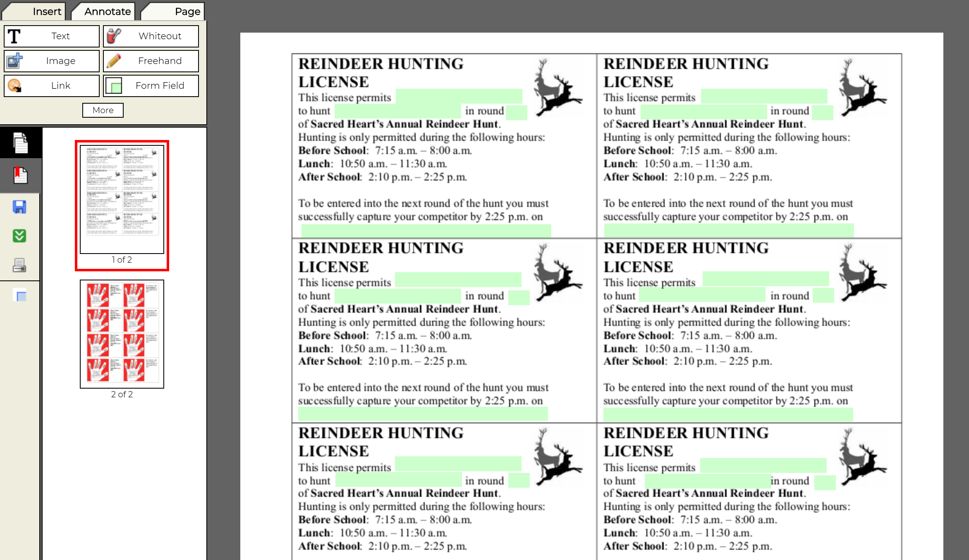

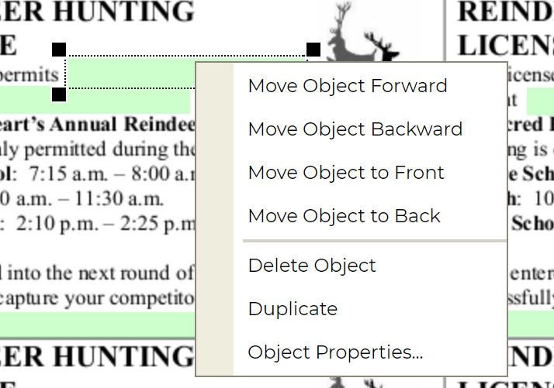Once they are all created, you need to select each one and assign it properties, by right clicking and selecting object properties on each of the form fields. Then, set the name of the form field following these guidelines:

If the form field is the placeholder for the first student in the match, it should have the base name of **Student1**. If it the field is the placeholder for the second student in the match, it should have the base name of **Student2**. Round end date placeholders must have the base name of **Date**. Round number placeholders should have the base name of **Round**.

**Then,** to these base names (except for the ones in the first add an underscore followed by the number it is. In the end, the fields should have the following names.



Student1

Student2

Student2_2

Student1_2

Student1_3

Student2_3

Student1_4

Student2_4

Round

Round_2

Round_3

Round_4

Date

Date_2

Date_3

Date_4

# First-time setup

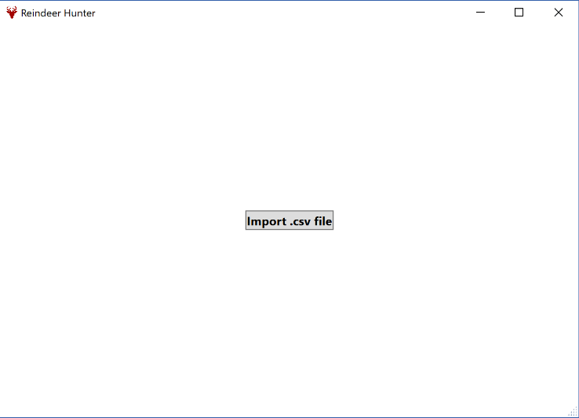The first time you open the program, the screen that appears should look like the picture to the side. There is only one action that can be taken at this screen: importing a .csv file.

This button is in fact prompting the user to import a .csv file. The .csv file in question is the file generated by the steps followed in the Student Information Spreadsheet section. This comma separated values (or .csv) file contains the necessary student data for the students you wish to manage during the Reindeer Hunt.

*Note that the option to Import Students becomes unavailable once round 1 of the hunt begins.*

Once students are properly imported, you should be taken to the Home Page of the program. This process of importing students could take some time, especially if you have a large number of students to import. If you encounter any errors during this stage, see the troubleshooting section.

# Home Page

The Home Page of the Reindeer Hunter program offers an overview of the current Reindeer Hunt as well as many of the actions that can be performed to manage the hunt.

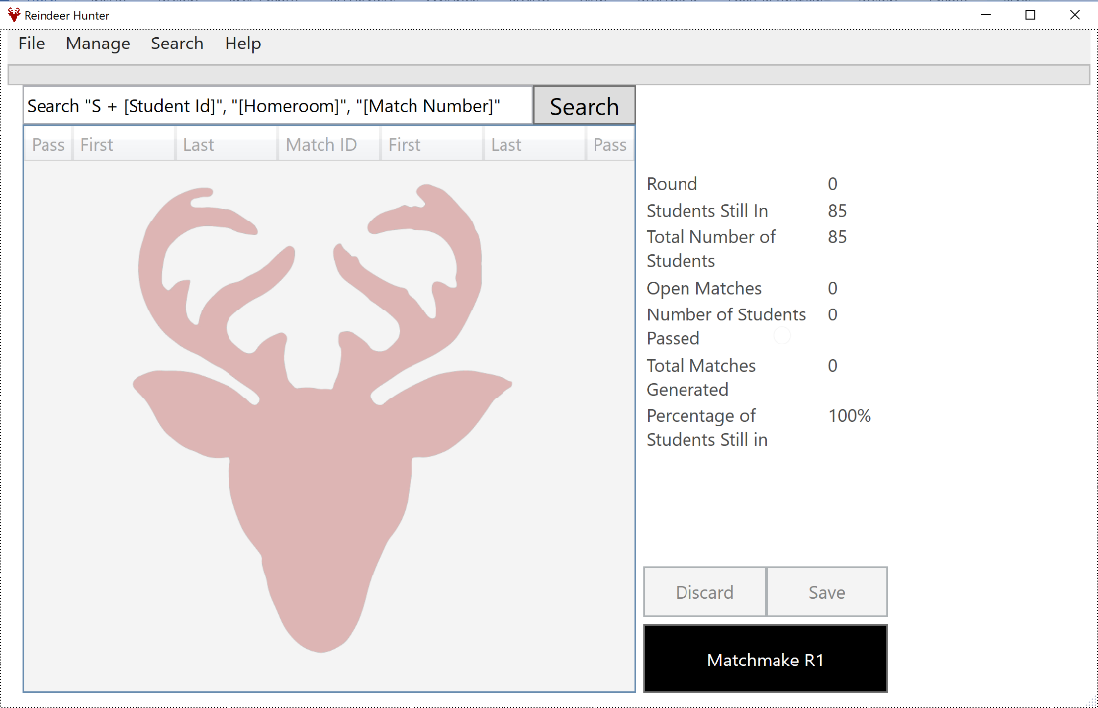

1. Main Process button

2. Save button

3. Discard button

4. Statistics Table

5. Match Display Table

6. Search Box

7. Menu Bar

|  |  |  |  |  |  |
| --- | --- | --- | --- | --- | --- |
| 1. Main Process Button | | | | | As the title suggests, this is the button for the major actions in the Reindeer Hunter program. It has three states: Matchmake, Instant Print and Go to FFA.  **Shortcut key: SPACE** |
|  | Matchmake | | | | When in the Matchmake state, clicking the Main Process Button will automatically generate matches with the students that are currently still in the hunt, and then displays them on the Match Display Table. Once created, the matches must be saved before any actions affecting these matches can be performed.  Save matches using the Save Button.  The Main Process Button will be in Matchmake state when sufficient students are still in the hunt to not be in Free For All state (Go To FFA state) and all matches are closed. |
|  | Instant Print | | | | When in Instant Print state, clicking the Main Process Button will generate a PDF file of Reindeer Hunt licenses filled with the current matches’ information.  If the template PDF file has not been imported already into the program, clicking the Instant Print button will prompt you to open the template PDF file.  Instant print will take the matches from the currenr round (open or closed) and create licenses with them. The licenses are sorted in increasing order by homeroom. At the last license for a grade, the remaining licenses on the last page for that grade will remain empty. This is so that the licenses for a certain grade can be coloured if the user so desires.  Once the process is completed, a file dialog will open prompting to save the newly filled licenses. If this is cancelled, the filled licenses will export to the current user’s desktop.  The Main Process button will be in this state when there are currently matches open in the current round.  *Note: The Instant Printer fill the licenses with all matches from the current round, even if they are closed.* |
|  | Go To FFA | | | | When in Go To FFA state, clicking the Main Process button changes the program to the Free For All page. See Free For All. |
| 2. Save Button | | | | | The Save button becomes enabled whenever an action causes a change that needs saving, such as Matchmaking or modifying matches in the Match Display Table.  Clicking it saves the modified content.  **Shortcut Key: S** |
| 3. Discard Button | | | | | The Discard button becomes enabled whenever an action causes a change that needs saving, such as Matchmaking or modifying matches in the Match Display Table.  Clicking it discards the modified content.  **Shortcut Key: D** |
| 4. Statistics Table | | | | | The Statistics table displays various data on the current round of the Reindeer Hunt. |
| 5. Match Display Table | | | | | The Match Display table displays matches based on the currently selected filters. See Filters and Search.  It also allows you to pass students into the next round by checking the checkbox next to the student and then saving.  On top of this, you can view information on either students or matches by double clicking on the cell that contains the Match ID or the student’s information. See Properties Window. |
| 6. Search Box | | | | | The Search Box acts alongside with the Filters and Search system to aid in sorting through matches or finding students. Matches, homerooms and students can be searched for.  Search for matches by entering the match id. See Match ID section for formatting of the match id.  Search for students in a homeroom by entering the homeroom’s number into the search box.  Search for students either by entering their full name, or their student number.  Submit your search using the Search button, or by pressing **Tab**. |
| 7. Menu Bar | | | | | The Menu Bar contains various menus. |
|  | | File Menu | | |  |
|  | |  | Import Data | | Imports exported Reindeer Hunt data. When this option is pressed, a file dialog will open, prompting to open a json file. This json file should contain data that you wish to import into the program.  To ensure that it is of the proper format, only ever import data that has been exported from the Reindeer Hunter program and has not been modified externally.  If an import error dialog pops up when importing a data file, the file that is being imported is of invalid format and cannot be imported, because the file has been modified outside of the Reindeer Hunter program. |
|  | |  | Export Data | | Exports the data for the current hunt to a json file that can be imported back into the program later. This can be used to save data for a particular year’s Reindeer Hunt or to create backups of the current hunt.  Once clicked, a file dialog will prompt you to save the json file somewhere.  Once exported, the file **must not** be modified as this could cause failure to import it back into the program. |
|  | |  | Erase Data | | Wipe the program, erasing all students, matches and preferences. This action cannot be undone. It is recommended to export data before erasing it, as this way it could be imported again later. |
|  | | Manager Menu | | |  |
|  | |  | | Import Students | Import more students from a comma separated values (csv) file. See Student Information Spreadsheet for proper formatting of this file. Note that this option is only enabled before the first round is made and saved. |
|  | |  | | Import Match Results | Import the results for matches from a comma separated values (csv) file. See Match Results.  This menu option is only enabled when there are matches open. |
|  | |  | | Export Students | Exports the current view the students that are currently on the Main Display Table) to a .csv file, ready for importing into a spreadsheet. It will be exported into the same format at the Student Information Spreadsheet. |
|  | | Search Menu | | | Provides various filters for searching.    Matches can be sorted by the round they belong to, or their status (open or closed). |

## Filters and Search

The filters menu options and the search box work together to display relevant content. That is, when searching for students or matches, the filters still apply. Therefore, it you attempt to find a closed match with only the open filter selected, you will not get any results.

By default, the filters are set to open matches in the current round only. Clearing the filters by pressing the clear button in the Search menu will reset them to this default.

## Match ID

The match id is unique to every match, and is in the following format:

Stands for match

The match’s round number.

The match’s generated number. No two of these numbers will be alike.

MAR1-1

# Properties Window

The properties window can be activated either for matches or students from either the Match Display Table in the Home Page or the Student Display Table on the Free For All page. Double clicking on either the match number or one of the students’ properties displays a new window containing information on that particular match or student.

When activated from the Home Page’s Match Display Table, student properties or matches can be double clicked on from the properties window to switch to seeing information on that student or match, without having to close the window and then find the relevant students or matches.

# Free For All Page

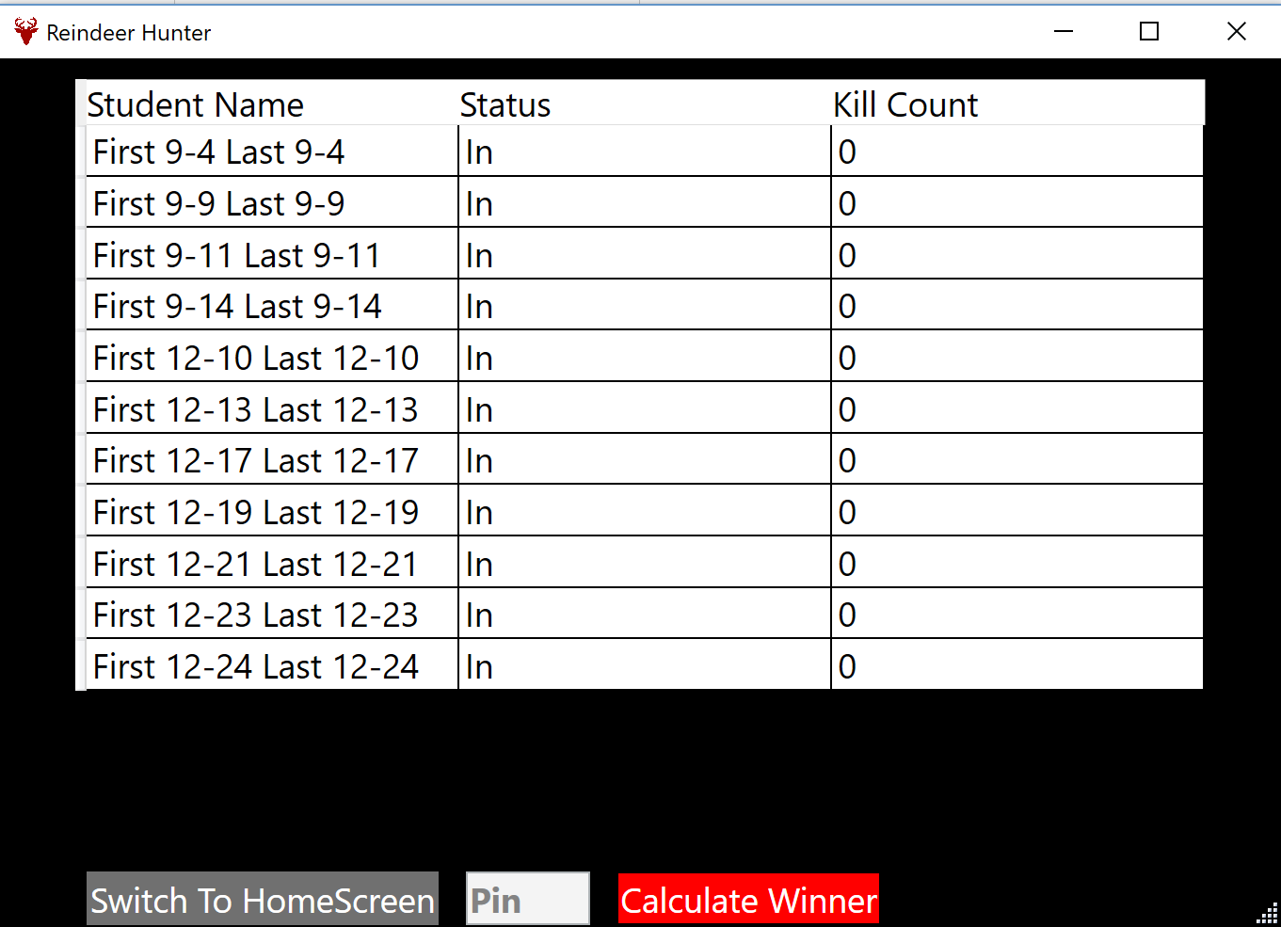

4. Switch to Home

1. Pin Button

2. Calculate Winner

3. Student Display Table

The free for all page is accessed by pressing the Main Process Button from the home page whenever it is enabled. See Home Page. This page is used to manage the free for all portion of the Reindeer Hunt.

|  |  |
| --- | --- |
| 1. Pin Button | The pin button is enabled only when a student that is still in the hunt is selected in the Student Display Table.  When this button is pressed while a valid student is selected in the Student Display Table, a dialog asking for the pinner of the selected student will show. Only students that are still in will be listed as options.    **Shortcut Key: P** |
| 2. Calculate Winner | The calculate winner button is enabled the entire time and is used to calculate who won the hunt. It does this by finding the student that is still in the hunt and who has the most kills of those still in the hunt.  If there is a tie of some sort, a prompt will open asking for the student that won the coin toss. You can close the program, do the coin toss with the students that tied and reopen the program and select the winner.  Once the winner is calculated, all actions which modify data in the Reindeer Hunter program will be blocked. You can still go back to the home page and browse students and matches though, and perform any other non-modifying actions. |
| 3. Student Display Table | The student display table displays all students in the free for all portion of the Reindeer Hunt. Unlike the match display table on the home page, it cannot be filtered or searched through.  Just like the match display table on the home page, you can double click any of the students’ properties and a properties window will open with information on that student. The properties window generated by the free for all page will contain more information than the regular properties window, such as who the student has pinned and how many pins they have. |
| 4. Switch To Home | The switch to home button switches to the home page.  **Shortcut Key: H** |